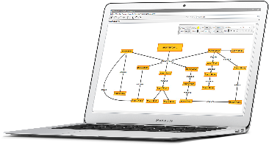

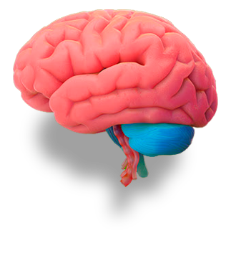
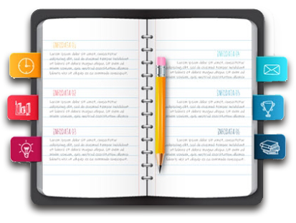

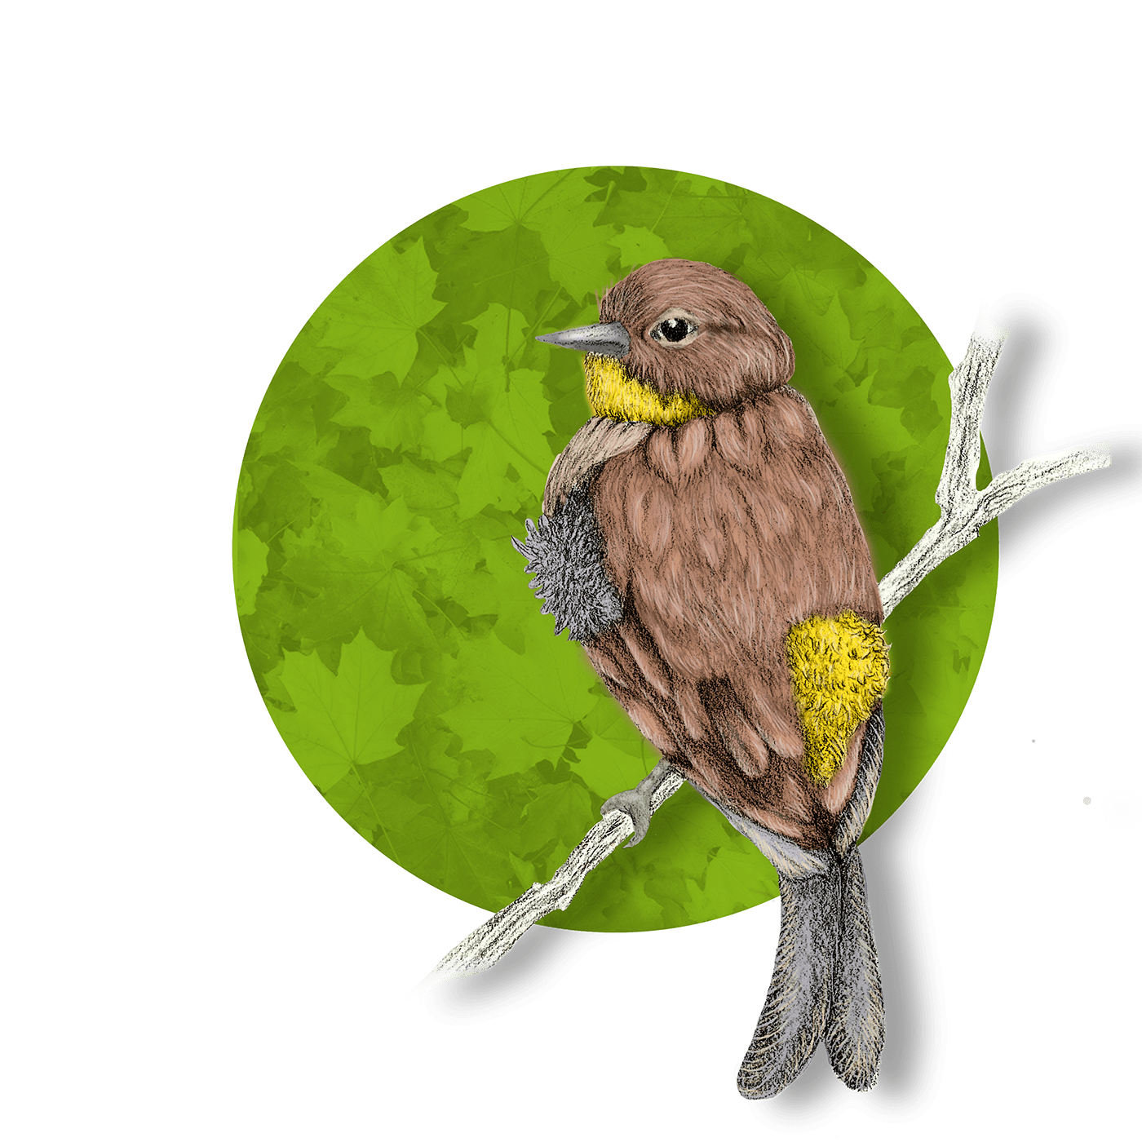
Lorem ipsum dolor sit amet, consectetur adipiscing elit, sed
Lorem ipsum dolor sit amet, consectetur adipiscing elit, sed
INFOGRAFIA
Lorem ipsum dolor sit amet, consectetur adipiscing elit, sed do eiusmod tempor incididun
Lorem ipsum dolor sit amet, consectetur adipiscing elit, sed do eiusmod tempor incididun
Lorem ipsum dolor sit amet, consectetur adipiscing elit, sed do eiusmod tempor incididun
Lorem ipsum dolor sit amet, consectetur adipiscing elit, sed do eiusmod tempor incididun
Lorem ipsum dolor sit amet, consectetur adipiscing elit, sed do eiusmod tempor incididun
Lorem ipsum dolor sit amet, consectetur adipiscing elit, sed do eiusmod tempor incididun
Lorem ipsum dolor sit amet, consectetur adipiscing elit, sed do eiusmod tempor incididun

